**Observation of robust magnetic order in monolayer NiPS3**

**EXPERIMENTS:**

Lili Hu1, Yuzhong Chen1, Kang Xu2, Peng Gu1, Ke Wu3, Yubin Wang2, Mengdi Zhang1, Haiyun Liu1, Qihua Xiong2,1

**CALCULATIONS:**

Hao-Xin Wang4, Ming-Rui Li4, Hong Yao2,4

1Beijing Academy of Quantum Information Sciences, Beijing 100193, P.R. China

2State Key Laboratory of Low-Dimensional Quantum Physics and Department of Physics, Tsinghua University, Beijing 100084, P.R. China

3School of Physics and Technology and Key Laboratory of Artificial Micro- and Nano-structures of Ministry of Education, Wuhan University, Wuhan 430072, China

4Institute for Advanced Study, Tsinghua University, Beijing, China

**Abstract**

Monolayer antiferromagnet of XY-type composes a pivotal part of the two-dimensional magnetism, but demonstrated few kinds at present. Because of the zero net magnetic moment and large spin fluctuation, the confirmation of XY-type monolayer antiferromagnet meets ambiguity occasionally and becomes an intriguing issue. As an important XY-type antiferromagnet and BKT-transition candidate, whether monolayer NiPS3 has magnetic order is still controversial. We studied the helicity resolved Raman and ultrafast spectroscopy of NiPS3 from bulk to monolayer. By analyzing the intrinsic two-magnon properties and transient absorptions, we found monolayer NiPS3 is magnetically ordered at low temperatures with a possible BKT-transition at *T*BKT = 140 K. We also performed density matrix renormalization group (DMRG) calculation to verify the zigzag-AFM magnetic ground state and Monte-Carlo simulations to verify BKT-transition in monolayer NiPS3. The theoretically obtained transition temperature *T*BKT of monolayer NiPS3 agrees well with the experiment. Our research establishes monolayer NiPS3 as an ordered XY-type antiferromagnet with possible BKT transition, consisting of an important platform for investigating complex couplings and topological excitations in two-dimensional magnetic materials.

The novel two-dimensional materials have provided an important platform for fundamental investigations and device fabrications. Electrons, phonons, spins, and excited quasiparticles in the two-dimensional (2D) limit exhibit peculiar confinement behaviors and strong interactions1. In recent years, great progress has been made in the study of two-dimensional magnetic materials2,3. According to the Mermin-Wagner theorem, long-range ferromagnetism (FM) and antiferromagnetism (AFM) in two-dimension with continuous global symmetry are expected to be forbidden at finite temperatures4. However, the single-ion anisotropy caused by spin-orbit coupling and the interaction between layers can assist the realization of two-dimensional long-range magnetic orders. A variety of two-dimensional magnetic materials have been experimentally verified recently, most of which are of Ising type5 or Heisenberg type6. In addition, it is theoretically proved there may exist a special topological Berezinskii-Kosterlitz-Thouless (BKT) transition at finite temperatures in an XY-like two-dimensional system, marked by the transition of bound vortice-antivortice pairs into free vortices7. The BKT-phase transition is found to have a tight correlation with superfluidity8, Bose-Einstein condensation9, and superconductivity10. Only in material systems fitted with XY (or XXZ-model with weak interlayer interaction), BKT-transition is possible to be observed experimentally.

Recently, important progress in many-body exciton11, magnon-phonon coupling12, and magnon-based device13 has been made in the field of 2D antiferromagnetic materials. The intralayer antiferromagnetic *M*P*X*3 (*M* = Fe, Ni, Mn, and *X* = S, Se) family has attracted much attention due to their (quasi)2D antiferromagnetism, rich spin dimensionalities, strong coupling between multi-degrees of freedom, and potential applications in quantum information technology14,15. With varying transition metal *M* among Fe, Ni, and Mn, the magnetism in *M*P*X*3 behaves as Ising-type (FePS3), XY-type (NiPS3), and Heisenberg-type (MnPS3). While the bulk *M*P*X*3 exhibit the *C*2*h* point group symmetry, the point group of the monolayer is *D*3*d*. NiPS3 inherits the lattice structure of *M*P*X*3 family, where intralayer Ni2+ ions form a honeycomb lattice16,17, as shown in Fig. 1a. Each Ni2+ has a magnetic moment of 3 μB (Bohr magneton). The Ni2+ ions with the same spin direction form the zigzag FM chains parallel to the *a*-axis and the FM chains are coupled in an AFM manner. At about 150 K, NiPS3 undergoes a phase transition from zigzag-AFM to PM (paramagnetism). Checking the temperature dependence of phonon splitting and linear dichroism suggested that zigzag-AFM exists only within thickness from bulk to bilayer, with monolayer found magnetically disordered due to enhanced spin fluctuation18,19. Meanwhile, theoretical studies suggested that there exists a magnetic order in the monolayer NiPS320,21. Even it is highly suspected BKT-transition exists in monolayer NiPS3, no phase transition has been detected till now. Whether there is a magnetic order in the monolayer NiPS3 and how to detect it has become an urgent problem in the field of two-dimensional magnetic materials. In addition, NiPS3 has been regarded as a platform to study the intertwining physical phenomenon between magnetism and other degrees of freedom, which has not been fully understood. To clarify the physical mechanism underlying the spin-coupled behaviors of charge, lattice, exciton, and magnon in two-dimensional limit and move further to manipulating these couplings, the experimental determination of magnetic order for NiPS3 monolayer is demanded. Here we report the experimental observation of robust magnetic order in monolayer NiPS3. This conclusion is supported by results of helicity resolved Raman and ultrafast spectroscopy, and assisted by theoretical calculations. All our experimental observations and theoretical calculations support the magnetic phase transition at ~140 K for monolayer NiPS3.

Figure 1a shows the schematic lattice structure and magnetic order of a single layer NiPS3. The upper panel of Fig. 1b shows the optical images of monolayer and bilayer NiPS3 on Si/SiO2 substrates, prepared by mechanical exfoliation methods (see details in Methods), for the purpose of helicity resolved Raman spectroscopy22. The three lower panels of Fig. 1b are the optical images of monolayer, bilayer, and thin bulk samples on transparent substrates (SiO2 for monolayer, and sapphire for bilayer and thin bulk) used for the ultrafast spectroscopy experiments. The AFM cross sections are presented in Fig. 1c to characterize the sample thickness. The helicity resolved Raman spectra of single crystal and monolayer NiPS3 at 30 K are shown in Fig. 1c and 1d, with the corresponding polarization configurations annotated at the right top corner of each panel, in which XX (XY) represents co- (cross-) linear polarization and σ+σ+ (σ+σ-) represent co- (cross-) circular polarization configurations, respectively. The main phonon peaks are assigned in spectra under σ+σ- and σ+σ+ polarizations to cover all the phonon peaks observed. As can be seen from Fig. 1c and 1d, according to the polarization dependence observed, all the phonon peaks can be understood based on *D*3d symmetry (the Raman tensor analysis of the *D*3d point group can be found in Supporting Information), which is in good agreement with previous literatures, implying weak interlayer interaction in the NiPS3 system23 and accordance with 2D-XY-model. With *D*3d point group, all Raman active modes can be divided into Ag (out-of-plane vibration) and Eg (in-plane vibration) modes24. When considering the weak interlayer interaction and symmetry lowering by zigzag-AFM order, the Eg modes can split into A and B modes, resulting in the frequency splitting of under different linear polarizations (XX and XY) as denoted by the dashed lines in Fig. 1c. Note that the frequency splitting of specific phonon peak at around 175 cm-1 was utilized as a criterion to determine the existence of zigzag-AFM order in NiPS3 in previous report18. Other than the narrow phonon peaks, there is a broad continuum scattering in Raman spectra as shown in Fig. 1c and 1d, which are identified to be two-magnon scattering (denoted as 2M mode) 18,25. The 2M signal is highlighted by a red shadow, resulted from a composite lineshape analysis. It can be seen from Fig. 1c and 1d that the 2M band only appears in XX, XY, and σ+σ- polarizations, while the scattering intensity under the σ+σ- is around twice of that under the XY polarization, indicating that the 2M modes belong to the Eg representation of *D*3d point group (see Supporting Information for detailed analysis).

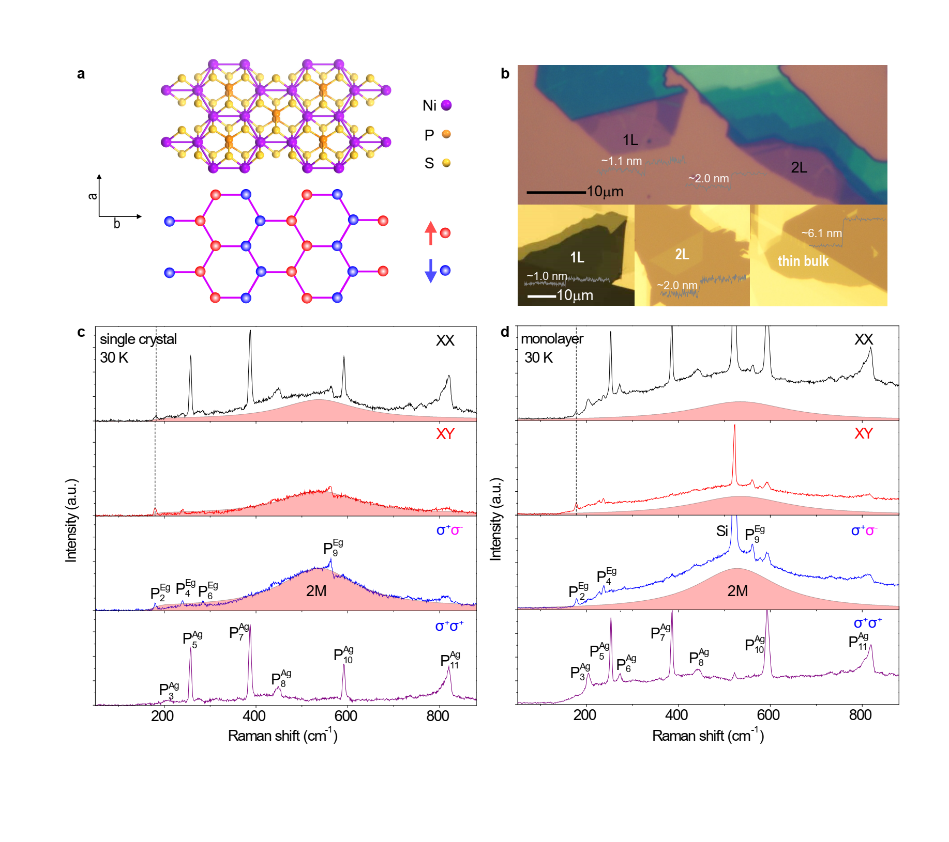

**Fig. 1 | The helicity resolved Raman spectra.** **a,** Lattice and magnetic structure of a single-layer NiPS3. **b,** Optical photographs of monolayer and bilayer NiPS3 for helicity Raman spectroscopy and monolayer, bilayer and thin bulk NiPS3 for ultrafast spectroscopy. **c and d,** Helicity-resolved Raman of single crystal and monolayer at 30 K.

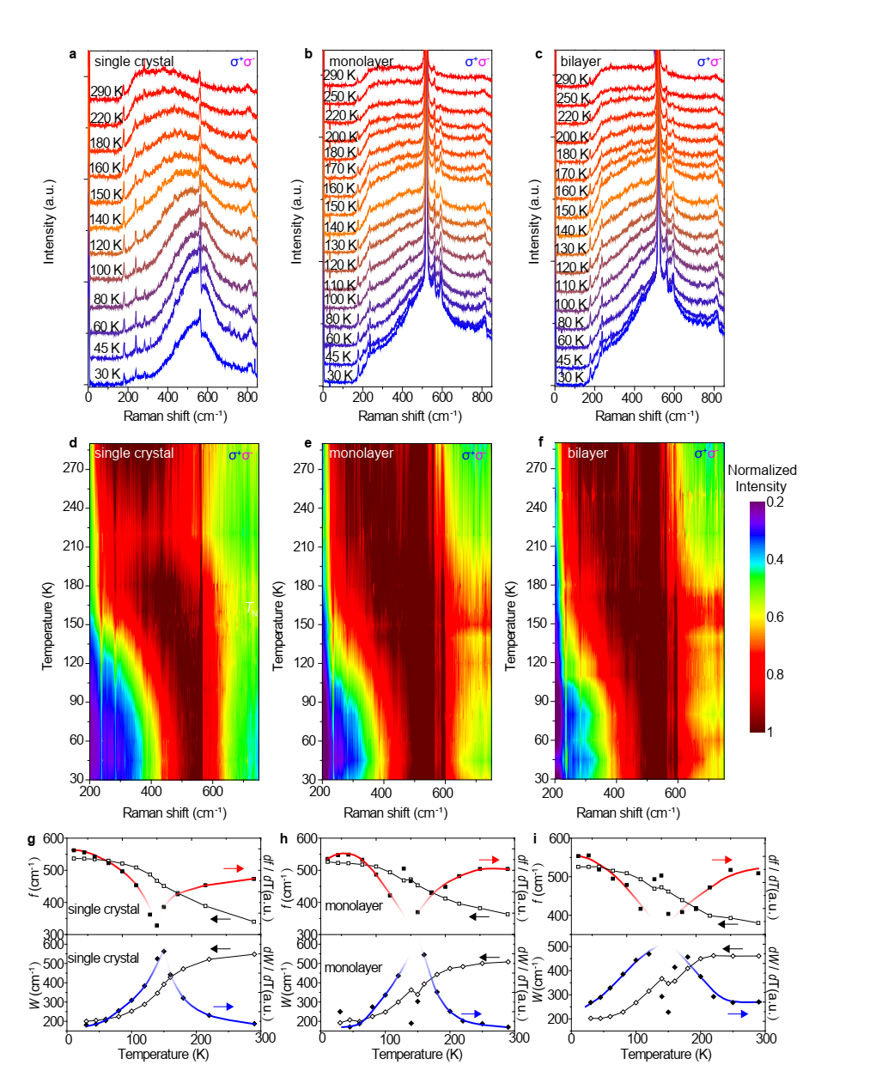 **Fig. 2 | Temperature-dependent Raman spectra of single crystal NiPS3 at σ+σ- polarization. a,** **b, and c,** Temperature-dependent Raman spectra of single crystal, monolayer, and bilayer NiPS3. **d,** **e, and f,** Colormaps of normalized Raman spectra at σ+σ- polarization for single crystal, monolayer, and bilayer NiPS3. **g-i**, Temperature dependence of *f*, *W*, *df*/*dT*, and *dW*/*dT* for single crystal, monolayer and bilayer at σ+σ- polarization.

Because the 2M band has overwhelming intensity and better signal-to-noise ratio under the σ+σ- polarization, the 2M properties are mainly analyzed from Raman spectra at σ+σ- polarization. Temperature-dependent Raman spectra of single crystals, monolayer, and bilayer (offset vertically for clarity) are shown in Fig. 2a, 2b, and 2c respectively. As the temperature increases from 30 K to 290 K, the 2M band becomes broader and its frequency redshifts remarkably. Although the intensity decreases with heating, the 2M band is still prominent even at 290 K. During all the temperatures the intensity at σ+σ- polarization keeps almost twice of that at XY polarization, obeying well to the *D*3d symmetry thus suggesting that in the whole temperature range the quasi-2D property of 2M can be maintained (see Supporting Information). To further elaborate the temperature evolution of 2M bands, we normalize the Raman spectra to the maximum of 2M band () under σ+σ- polarization, and plot the normalized Raman spectra into colormap graphs, as shown in Fig. 2d, 2e and 2f. From the colormaps, we can see that the frequency *f* and width *W* of 2M bands all show abrupt changes at *T* ≈ 150 K for single crystal, monolayer, and bilayer. It is well known that the Néel temperature *T*N ≈ 150 K for bulk NiPS3 corresponds to antiferromagnetic-to-paramagnetic phase transition19,20. Thus the 2M properties indicate a magnetic phase transition for the NiPS3 system of different thicknesses at ~150 K. We plot frequency *f* and width *W* of 2M with temperatures in Fig. 2g-2i to clarify the temperature-dependence of 2M properties, especially the remarkable change at magnetic phase transition temperature. The frequency *f* and width *W* are shown by the open squares and open diamonds in Fig. 2g-2i. We also obtain first order differential of *f* and *W* versus temperature for single crystal, monolayer, and bilayer as shown by the solid squares and solid diamonds in Fig. 2g-2i, while the red and blue curves are guides for the eyes. The emergence of singularity points of *df* / *dT* and *dW* / *dT* at ~140 K for monolayer strongly proving that monolayer NiPS3 has robust magnetic order at low temperature.

We further investigate the transient absorption spectra of the monolayer, bilayer, and thin bulk NiPS3 at variable temperatures, pumped by a 385 nm femtosecond laser pulse (see Methods for details). Figure 3a shows the steady-state absorption spectra of monolayer and thin bulk at 60 K and 240 K, respectively. The centers of the absorption peaks are about 570 nm and 560 nm for thin bulk and monolayer respectively, and the absorption peaks have a slight redshift with the increase of temperature. The wavelength chosen for analyzing the magnitude of the time-resolved ΔT/T is 532 nm to keep consistent with the Raman excitation wavelength (for other probe wavelengths, see Supporting Information). Figure 3b shows the temperature-dependent ultrafast dynamics of monolayer NiPS3 from 60 K to 240 K, offset vertically for clarity. The colormap by plotting ΔT/T versus the time delays and the temperature (60-240 K) are displayed in Fig. 3c-3e for monolayer, bilayer, and thin bulk respectively. As shown in Fig. 3c and 3d, for the monolayer and bilayer samples, the general variation tendency of ΔT/T is decreasing with the increase of temperatures, but there is a maximum value near 150 K 26,27, which indicates that the phase transitions of monolayer and bilayer NiPS3 occurring at about 150 K. For the thin bulk as shown in Fig. 3e, the change of the color scale in 120 K -170 K is less sensitive to indicate the phase transition. We further extract the (ΔT/T)max of monolayer, bilayer, and thin bulk samples to plot versus the temperature, as shown in Fig. 3f, vertically offset for clarity (the offset values are 5×10-3 for bilayer and 1×10-2 for monolayer). It can be seen that a plateau-like region of (ΔT/T)max appear at about 150 K for all samples, signifying the magnetic phase transition for monolayer, bilayer, and thin bulk samples. The transition temperatures extracted from Fig. 3f are 160 K for bulk, 150 K for bilayer and 140 K for monolayer. Combined with the helicity-resolved Raman spectroscopy results, we assign the plateau-like feature at about 150 K to magnetic phase transition in NiPS3 system. A noticeable trend was also observed, *i.e,* with the thinning of the layers, the phase transition temperature shows a slight decrease, from about 160 K of bulk to about 140 K of the monolayer sample. Since NiPS3 is of XY-type, with the thinning of the layers, it is likely that the phase transition changes from AFM-PM phase transition for the bulk to BKT-transition for the monolayer.

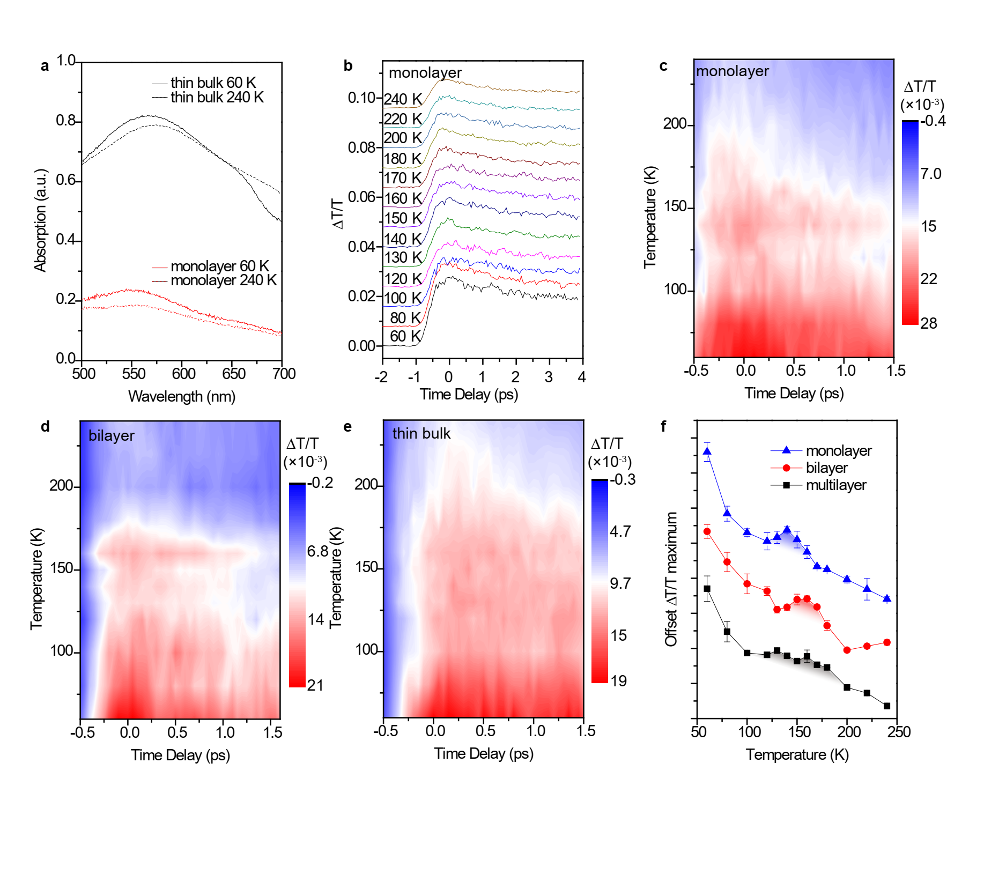

**Fig. 3 | Ultrafast spectroscopy investigation of NiPS3. a,** The steady state absorption spectra of monolayer and thin bulk at 60 K and 240 K. **b,** The temperature-dependent ultrafast dynamics of monolayer NiPS3. **c, d, and e,** The colormap of time-resolved ΔT/T for monolayer, bilayer, and thin bulk NiPS3. **f,** The temperature dependent of (ΔT/T)max for monolayer, bilayer, and thin bulk.

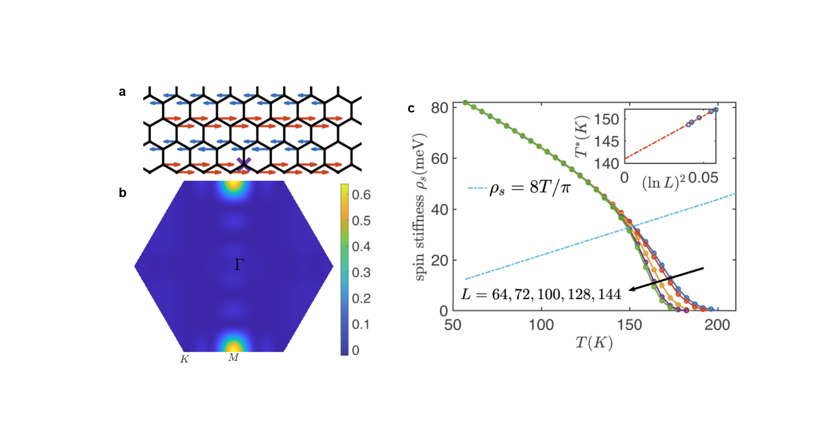

**Fig. 4 | Numeric evidences of the zig-zag order for monolayer NiPS3.** **a,** in-plane spin correlations. **b,** sublattice spin structure factor for the ground state of the J1-J2-J3-D model, calculated by DMRG. **c,** Temperature dependence of the MC-computed spin stiffness at different linear size .

We further performed theoretical calculation of monolayer to identify the magnetic ground state at zero temperature, to verify the BKT-transition, and to obtain phase transition temperature *T*BKT. Several theoretical models proposed in previous works have predicted the presence of the magnetic order in the monolayer NiPS3 but with phase transition temperatures disagree with our experimental results21,23,28. To shed further light on the monolayer NiPS3 system, we demonstrated a model that captures the distinguishing physics of our specific 2-dimensional quantum system. We considered a minimal effective spin-1 model including dominating spin-exchange coupling and single-ion anisotropy (SIA) which can be written as

where , and represent the nearest, the next-nearest, and the third-nearest neighbor (NN, NNN, and TNN) sites and , respectively. Note that only term survives in the general form of SIA with the restoration of symmetry in monolayer. According to previous DFT calculations21,29, anisotropy appearing in spin-exchange interaction is small in single crystals and will be further suppressed in 2D on consideration of the symmetry. We chose the following set of parameters compatible with DFT results: To investigate the low-temperature magnetic order of the model, we implemented a large-scale density matrix renormalization group (DMRG) calculation to find the ground state properties. We show the spin order on a so-called YC6-cylinder in Fig. 4 a and 4b. The length of the red and blue arrows in Fig. 4a is proportional to the amplitude of the spin-correlation .Referred from a central site at , which is marked as a purple cross in Fig. 4 a, in-plane spin correlations show a long-range zig-zag antiferromagnetic order along the leg of the cylinder (-direction), with a relatively small spin direction correlation , indicating an easy-plane spin orientation, *i.e.* monolayer NiPS3 can be applied to XY-model. Figure 4b shows the sublattice spin structure factor . The sole peak around point as shown in Fig. 4b confirms the zig-zag order at zero temperature and gives the value of the magnetic moment , which is close to our spin-wave prediction . Such a value of magnetic moment close to 1 indicates the magnetic order is close to the classical limit. In addition, we explored the magnetic order on XC-cylinder which also exhibit a zig-zag order (see details in Supporting Information)..

According to the Mermin-Wagner theorem, a 2-dimensional model with U(1) symmetry forbids long-range magnetic order at finite temperature but leaves the possibility of the Berezinskii-Kosterliz-Thouless transition. As the Nambu-Goldstone mode is associated with the breaking of U(1) symmetry, the corresponding magnon excitations can still be probed by the Raman spectra. To justify the possibility of the XY phase transition, we simulated the model based on the classical Monte-Carlo method and determine the phase transition temperature by spin stiffness. We show the results of the different system sizes in Fig. 4c. The blue dashed line is the relation between stiffness and the BKT phase transition point predicted by renormalization group analysis. The transition temperatures of finite-size systems are determined by the intersection point of the line with the stiffness curves. Then the finite size extrapolation of the intercept between v.s. leads to the transition temperature , as shown in inset of Fig. 4c. Our calculation shows the transition temperature of monolayer NiPS3 occurs at around 141 K, very close to the experimental result 140 K. Note that the transition temperature is not sensitive to the magnitude of the SIA (see details in Supporting Information).

**Discussion**

As we have discussed above, the BKT phase transition offers an interpretation of the magnetic order in monolayer NiPS3.­­­ Besides, it can also explain why some of the previous experiments claim opposite results to ours18,19. Due to the presence of antiferromagnetic vortices below the critical temperature *T*BKT, the orientation of the local antiferromagnetic order rotates as vortices in the sample. The frequency splitting between phonon peak under XX and XY polarizations and the linear dichroism effect which were proposed to indicate the magnetic order18 will be averaged21 if the rotational symmetry is restored at lone-range level as the BKT phase does, thus they did not observe BKT phase transition. And the lack of the long-range order will also make the photoluminescence and optical reflection spectroscopy measurements unable to detect the orders and phase transition in the monolayer NiPS3 system.

Strong two-magnon scattering is one of the characteristic excitations in AFM materials30. The critical behavior of 2M frequency at *T*N has been reported for antiferromagnets such as RbMnF3 and FeF231, due to the change of spin-correlation at magnetic phase transition temperature32. Here in NiPS3 systems, the (meta-)long-range spin correlation at *T* < *T*N (*T*BKT) is replaced by the short-range spin fluctuation at *T* ≥ *T*N (*T*BKT), leading to the redshift of 2M frequency at *T*N (*T*BKT) observed in Fig. 2. In addition, the linewidth of 2M band can also experience a sudden change nearing the temperature that spin-wave gap closes, *i.e.* *T*N, or the temperature that bound vortice-antivortice pairs form, *i.e.* *T*BKT. Below *T*N (*T*BKT), the spin excitations condense into sharp magnon or two-magnon mode due to the enhanced spin-correlation. With temperature increases to *T*N (*T*BKT), the enhancement of the thermal excitation and the spin fluctuation will provide more relaxation pathways to the 2M excitation at *T* ≥ *T*N (*T*BKT), so the linewidth of 2M band can also increase abruptly at *T*N (*T*BKT)33. Thus the temperature dependence of intrinsic properties of 2M mode in NiPS3 indicates magnetic phase transition effectively, *i.e.* both AFM-PM transition and BKT-transition. As shown in our work, for monolayer, the temperature-dependent frequency and linewidth of 2M band confirm the existence of magnetic order, showing that 2M scattering which mainly relies on the spin-correlation is a robust tool for studying magnetic ordering and providing an important enlightenment for the field. Since monolayer NiPS3 is of XY-type without interlayer interaction, it is the BKT-transition that most likely happens in it.

In transient spectroscopy, pump laser is used to perturb the dielectric properties of the sample while probe laser is used to detect change of the reflection or transmission. Since a phase transition can usually accompany the change of dielectric functions, the time-resolved differential reflection (ΔR/R) or transmission (ΔT/T) can be used to detect the phase transition of materials26,27. Usually ΔR/R or ΔT/T is proportional to the number density of excited quasiparticles. Since there is strong spin-charge coupling and spin-phonon coupling in NiPS318,34, the magnetic phase transition can change the dielectric function and ΔT/T can reflect the magnetic phase transition. For NiPS3 from bulk to bilayer, it is therefore reasonable to assume that the pump induced excitation of a quasiparticle from the spin ground state to above the spin-wave gap will contribute to the differential ΔT/T. As the temperature rises to near *T*N, the spin-wave gap decreases and the high-energy phonons produced by carrier relaxation can excite the spin from the ground state to above the spin-wave gap, bringing an additional increase of ΔT/T at a temperature near *T*N. This may be one of the important reasons why we can observe the magnetic phase transition in NiPS3 samples from bulk to bilayer by ultrafast spectroscopy. In addition, in NiPS3 monolayer of XY-type the ultrafast dynamics can also be used to identify the magnetic order. A recent theoretical investigation has pointed out after a possible BKT-phase transition in monolayer NiPS3, the breaking of bound vortice-antivortice pairs into free vortices can contribute to the change of dielectric function across *T*BKT, which can qualitatively explain the peak of (ΔT/T)max we observe in monolayer NiPS3 here. Combining the results of 2M properties, temperature dependent (ΔT/T)max and theoretical calculation, we can prove there is still robust magnetic order exist in monolayer NiPS3, whose magnetic phase transition is possible of BKT-type.

**Conclusion**

In summary, by studying the helicity-resolved Raman spectroscopy and the ultrafast spectroscopy with various thickness down to monolayer, we unambiguously identify magnetic order in NiPS3 from bulk to monolayer. By examining the 2M properties and transient absorptions, we identify the phase transition temperatures of NiPS3 samples with different thicknesses, which are 160 K for bulk and 140 K for monolayer, possibly followed by a changing of AFM-PM phase transition in bulk to BKT-transition in monolayer. Theoretical simulations show monolayer NiPS3 has zigzag-AFM order at zero temperature and BKT-transition at finite temperatures. Our work settles monolayer NiPS3 as a 2D XY-type antiferromagnetic platform for topological excitations and magnetism engineering.

**References**

1 Butler, S. Z. *et al.* Progress, challenges, and opportunities in two-dimensional materials beyond graphene. *ACS nano* **7**, 2898-2926 (2013).

2 Gong, C. & Zhang, X. Two-dimensional magnetic crystals and emergent heterostructure devices. *Science* **363**, eaav4450 (2019).

3 Gibertini, M., Koperski, M., Morpurgo, A. F. & Novoselov, K. S. Magnetic 2D materials and heterostructures. *Nature nanotechnology* **14**, 408-419 (2019).

4 Mermin, N. D. & Wagner, H. Absence of ferromagnetism or antiferromagnetism in one-or two-dimensional isotropic Heisenberg models. *Physical Review Letters* **17**, 1133 (1966).

5 Huang, B. *et al.* Layer-dependent ferromagnetism in a van der Waals crystal down to the monolayer limit. *Nature* **546**, 270-273 (2017).

6 Gong, C. *et al.* Discovery of intrinsic ferromagnetism in two-dimensional van der Waals crystals. *Nature* **546**, 265-269 (2017).

7 Kosterlitz, J. M. & Thouless, D. J. Ordering, metastability and phase transitions in two-dimensional systems. *Journal of Physics C: Solid State Physics* **6**, 1181 (1973).

8 Clade, P., Ryu, C., Ramanathan, A., Helmerson, K. & Phillips, W. D. Observation of a 2D Bose gas: from thermal to quasicondensate to superfluid. *Physical review letters* **102**, 170401 (2009).

9 Simula, T. P. & Blakie, P. Thermal activation of vortex-antivortex pairs in quasi-two-dimensional Bose-Einstein condensates. *Physical review letters* **96**, 020404 (2006).

10 Blatter, G., Feigel'man, M. V., Geshkenbein, V. B., Larkin, A. I. & Vinokur, V. M. Vortices in high-temperature superconductors. *Reviews of modern physics* **66**, 1125 (1994).

11 Kang, S. *et al.* Coherent many-body exciton in van der Waals antiferromagnet NiPS3. *Nature* **583**, 785-789 (2020).

12 Liu, S. *et al.* Direct observation of magnon-phonon strong coupling in two-dimensional antiferromagnet at high magnetic fields. *Physical Review Letters* **127**, 097401 (2021).

13 Chen, G. *et al.* Electrically switchable van der Waals magnon valves. *Nature communications* **12**, 1-5 (2021).

14 Jiang, X. *et al.* Recent progress on 2D magnets: Fundamental mechanism, structural design and modification. *Applied Physics Reviews* **8**, 031305 (2021).

15 Rahman, S., Torres, J. F., Khan, A. R. & Lu, Y. Recent Developments in van der Waals Antiferromagnetic 2D Materials: Synthesis, Characterization, and Device Implementation. *ACS nano* (2021).

16 Susner, M. A., Chyasnavichyus, M., McGuire, M. A., Ganesh, P. & Maksymovych, P. Metal thio‐and selenophosphates as multifunctional van der Waals layered materials. *Advanced Materials* **29**, 1602852 (2017).

17 Bernasconi, M. *et al.* Lattice dynamics of layered MPX3 (M= Mn, Fe, Ni, Zn; X= S, Se) compounds. *Physical Review B* **38**, 12089 (1988).

18 Kim, K. *et al.* Suppression of magnetic ordering in XXZ-type antiferromagnetic monolayer NiPS3. *Nature communications* **10**, 1-9 (2019).

19 Hwangbo, K. *et al.* Highly anisotropic excitons and multiple phonon bound states in a van der Waals antiferromagnetic insulator. *Nature Nanotechnology* **16**, 655-660 (2021).

20 Sivadas, N., Daniels, M. W., Swendsen, R. H., Okamoto, S. & Xiao, D. Magnetic ground state of semiconducting transition-metal trichalcogenide monolayers. *Physical Review B* **91**, 235425 (2015).

21 Kim, T. Y. & Park, C.-H. Magnetic Anisotropy and Magnetic Ordering of Transition-Metal Phosphorus Trisulfides. *Nano Letters* (2021).

22 Zhao, Y. *et al.* Abnormal intensity and polarization of Raman scattered light at edges of layered MoS2. *Nano Research*, 1-6 (2022).

23 Lançon, D., Ewings, R., Guidi, T., Formisano, F. & Wildes, A. Magnetic exchange parameters and anisotropy of the quasi-two-dimensional antiferromagnet NiPS3. *Physical Review B* **98**, 134414 (2018).

24 Kuo, C.-T. *et al.* Exfoliation and Raman spectroscopic fingerprint of few-layer NiPS3 van der Waals crystals. *Scientific reports* **6**, 1-10 (2016).

25 Rosenblum, S., Francis, A. & Merlin, R. Two-magnon light scattering in the layered antiferromagnet NiPS3: spin-1/2-like anomalies in a spin-1 system. *Physical Review B* **49**, 4352 (1994).

26 Chu, H. *et al.* A charge density wave-like instability in a doped spin–orbit-assisted weak Mott insulator. *Nature Materials* **16**, 200-203 (2017).

27 Tian, Y. *et al.* Ultrafast dynamics evidence of high temperature superconductivity in single unit cell FeSe on SrTiO3. *Physical Review Letters* **116**, 107001 (2016).

28 Chittari, B. L. *et al.* Electronic and magnetic properties of single-layer m P X 3 metal phosphorous trichalcogenides. *Physical Review B* **94**, 184428 (2016).

29 Gu, Y. *et al.* Ni-based transition metal trichalcogenide monolayer: A strongly correlated quadruple-layer graphene. *Physical Review B* **100**, 165405 (2019).

30 Fleury, P. & Loudon, R. Scattering of light by one-and two-magnon excitations. *Physical Review* **166**, 514 (1968).

31 Fleury, P. A. Temperature Dependence of Magnon‐Pair Modes in Antiferromagnets and Paramagnets. *Journal of Applied Physics* **41**, 886-888 (1970).

32 Brya, W. & Richards, P. M. Frequency moments for two-spin light scattering in antiferromagnets. *Physical Review B* **9**, 2244 (1974).

33 Gretarsson, H. *et al.* Two-magnon Raman scattering and pseudospin-lattice interactions in Sr2IrO4 and Sr3Ir2O7. *Physical review letters* **116**, 136401 (2016).

34 Kim, S. Y. *et al.* Charge-spin correlation in van der Waals antiferromagnet NiPS3. *Physical review letters* **120**, 136402 (2018).